Getting everyone back together safely – 1st Oxshott

Oxshott Scout Group COVID-19 Policy
Version 3: updated 6th September 2020

A working document with details of actions/response taken in response to the guidance published at https://www.scouts.org.uk/volunteers/scouts-at-home/getting-everyone-back-together-safely/

Amendment Record

Version | Date Issued | Amendments Made
DRAFT | 14th July 2020 | n/a
UP-DATED DRAFT  VERSION 1 | 4th August 2020 | Following meeting on 14th July with leaders and 5th August with trustees this document was revised.
Updated – Version 2 | 31st August | To get action plan / response onto website – updated for ease for Parents.
Updated – Version | 6th September | Following change in permissions of Amber

Oxshott Scout Group COVID-19 Policy

Introduction and Key Supporting Info

On 25th June 2020 The Scouts published their “Getting everyone back together safely” guidance.

The Scouts are working with the National Youth Agency (NYA) government body to understand what a safe return to face to face activities may look like when the NYA readiness level reduces from RED.

There is a framework and set of guidance on how elements of face to face Scouting could take place and the safety measures we would need to take into account.

The guidance is published at:
https://www.scouts.org.uk/volunteers/scouts-at-home/getting-everyone-back-together-safely/

The Framework

The Scouts Framework is aligned with Government-approved guidance for the Youth Sector developed by the NYA. This framework will apply in every nation within UK Scouting.
It covers:
- the permissions process for restarting any face to face activity
- the key considerations to be ready to restart face-to-face activities and how these will be phased
- legal and liability conditions
- key control measures for everyone to follow

Basics

Scout Groups (and sections within) make the decision as to when they will get back to face-to-face activities but decisions will be made in line with the national framework.
Section Leaders, Group Scout Leaders, Commissioners and Executive Committee members need to make sure that plans for restarting face-to-face meetings and activities are developed so that volunteers and young people at all times:
- Comply with social distancing requirements (determined by their government)
- Ensure hygiene levels are maintained, including hand washing, as well as surface and equipment cleaning
- Safely manage any risk to volunteers, young people and the wider community, including a reduction in group sizes where necessary
- Make sure vulnerable young people and adults can be effectively safeguarded, both in relation to COVID-19, as well as other risk factors
- Volunteers, parents/carers and young people all clearly understand what adjustments need to be made to ensure everyone’s safety, and have had a chance to inform them

Phased Return

This diagram sets out the permitted activity at each phase.
The details are subject to (and likely to) change with updated NYA guidance.
The latest definition of a ‘large group’ and a ‘small group’ can always be found at:
https://www.scouts.org.uk/volunteers/scouts-at-home/getting-everyone-back-together-safely/readiness-levels-across-uk-scouts/

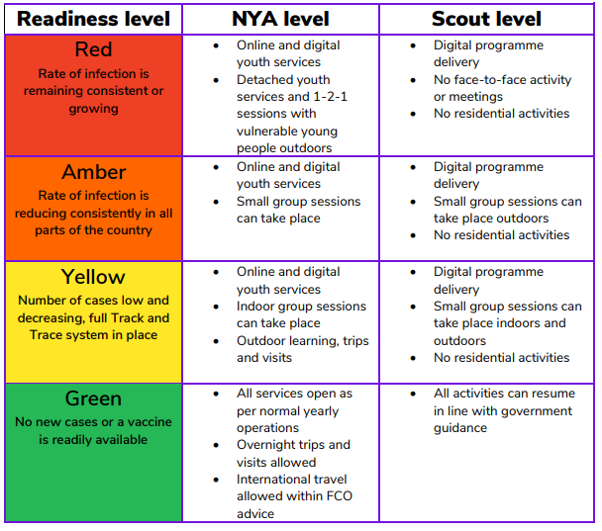

When levels change (as confirmed by the NYA and equivalents), Scout Groups will need to revisit and, update their written risk assessments and action plans. They will also need to gain permission from their District to enter the next phase. However, if lockdown measures increase and the readiness level escalates (e.g. Amber to Red), Groups are expected to revert to previous practice immediately and notify line-managers, rather than ask for approval.

This document and supporting risk assessments will be updated accordingly.

The Approval Process

The Group Scout Leader and the Chair of the Group Executive are required to state that the group, in whole or part, is ready to restart face-to-face activity safely. Before starting, all evidence of written risk assessments must be approved and signed off by the nominee of the District Executive and District Commissioner, and written agreement of such approval recorded. These records should also be accessible to County Commissioners and their teams.

Risk assessments should be emailed to esherscouts@gmail.com at least 7 days before the proposed resumption date for feedback and advice.

All risk assessments must be uploaded using the online form on scouts.org.uk in order to get formal approval before you are permitted to restart. The District Approvers are Andrew Burns, Mark Aulds, Harry Jones and Gary Ernest.

The District Approvers email is esherscouts@gmail.com.

The uploader is accessed under Request to re-start your Group on the Getting everyone back together safely webpages.

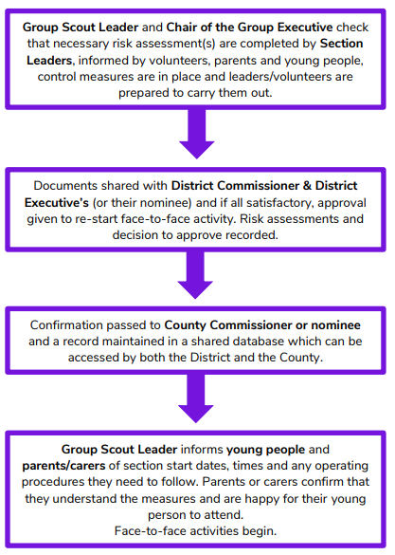

Insurance and Legal Considerations

The Scout Group must comply with the rules and policies of The Scouts in order to remain insured. The framework to which our actions/response is based is an approved policy and therefore all steps need to be met. It is the responsibility of the Scout Group’s trustees to ensure this takes place and that risk is regularly reviewed in and around the Scout meeting place and that controls are implemented and updated.

Guidance provided by The Scouts

The Scouts have produced guidance on the following topics. These documents have been used to (and will be used to) support decision making at the Scout Group. All leaders should read and be familiar with this guidance.

- Planning a safe and enjoyable programme
- Speaking with parents, carers and young people
- Getting everyone there safely
- Working safely with the public
- Knowing what to do if something goes wrong
- Supporting those made more vulnerable by the crisis
- Protecting ourselves and others
- What to do when our buildings are used by others
- Keeping our buildings safe and secure
- Finding a safe place to meet
- Getting Scouts back into the great outdoors – campsites and activity centres
- Helping others get back into the great outdoors – guidance on reopening our campsites and activity centres to the public and third parties
- Running/participating in DofE during the pandemic

Getting our Sections Back Together Safely

It is recommended that a blended approach be taken to planning programmes over the next few months. We should not rule out Virtual Scouting altogether but aim to reduce it and focus the shift onto the outdoor activities our members have been missing out on.

Remember, a move back to RED could happen at any point so we must be prepared for this and an abrupt stop of any face-to-face programme.

Face-to-face activities can take place when the readiness level is at AMBER, YELLOW or GREEN.

A COVID-19 specific ‘restarting Scouting’ Risk Assessment must be completed at section level for face-to-face activity. This Risk Assessment must be approved by the district as per the approval process.
An activity Risk Assessment should also be completed (as usual) for each activity taking place, but this does not need to be approved by the District as it is not specific to the resumption of face-to-face activities.

For activities based at the Hut, sections will share the same ‘base risks’. These have been summarised and suitable control measures implemented in a group risk assessment template Section Leaders should use as a base for their section risk assessments.

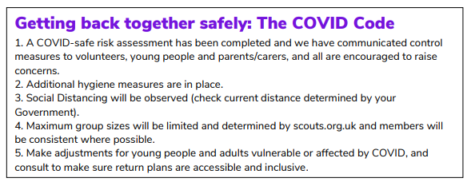

We must consider

These are high level points, but ones that need to be considered when considering risks and our response/control measures:

- Selecting suitable activities, taking into account distancing and the allowable group sizes. We will have up to two groups at once – separated as per guidelines.
- The meeting venue (not necessarily the Hut)
- The format of the meeting (our traditional format won’t be possible)
- The availability of leaders (can we meet ratios and still make the activities work?)
- Hygiene practices
- Arrival and departure
- Cleaning (of the Hut if meeting there/any equipment used)

Suitable Activities

Remember, we are considering outdoor activities over indoor activities during AMBER.
This is valuable guidance from The Scouts that has and will continue to influence our decision making.

Group size - Session planned in line with latest guidelines on group size, group distancing and meeting format. Basing programmes around patrols, sixes and lodges provides some flexibility to scale meetings up and down if the group size guidelines change.
Multiple groups – Plan for full participation if the section is larger than the maximum group size, e.g. Run parallel, separate face-to-face sessions in different locations. If these are in a single open space there should be at least 25m between groups and different start times or meeting points. Run video and face-to-face sessions in parallel. Run sessions sequentially with thorough cleaning in between. Meet with part sections on alternative weeks
Venue - Suitable outdoor venue agreed: e.g. provision for tarps, shelters, etc., in case of wet weather and all members bringing appropriate clothing. Use of indoor toilets and kitchens to support outdoor meetings is permitted. When new venues are built into your programme, make sure they are risk assessed too.
Logistics – Where multiple groups are at the same venue, arrangements for keeping groups separate are in place, including for arrival and drop off.
Toilets - Where meetings share toilets, plan use to prevent infection, e.g. different breaks, routes avoiding other groups, allocating separate facilities, regular cleaning/hand washing.
Session length - Restrict face-to-face meetings to the shortest session that can contain an exciting and educational programme. For your first socially distant meetings try no more than an hour for Beavers/Cubs and no more than ninety minutes for Scouts/Explorers.
Inclusion - Your venue and programme should allow as many section members to participate as often as possible. Where children with additional needs require individual assistance, this is best provided by one of their household, since distancing rules don’t apply
Adult support – Make sure you have enough adult help to run your meeting, respecting current section supervision ratios, shielding, and personal choice. Young Leaders should be fully involved in planning and delivering content, but should not undertake first aid or cleaning.
Communications – All young people, parents/carers and volunteers briefed in advance. InTouch in place. Volunteers assigned to monitor distancing, cleaning, arrivals / departures
Risk assessment – Risk assessment has been written and reviewed in line with guidance.

Suitable Locations

You must consider principles of safety and safeguarding and include in your risk assessments all non-COVID-19 hazards in choosing an outdoor location as suitable for face-to-face activities.
- Will others be meeting in the same location at the same time?
- Who owns and controls the space? What restrictions do they have on its use at this time?
- How big a space is required for the type of activity taking place and the number of people taking part?
- Are there suitable facilities available for hand washing, hygiene, toilets etc.?
- Is shelter available (e.g. from sun or rain?)
- Are parents/carers able to safely drop off and pick up their children, both as planned, and in an emergency?

Response to items on the Approver Checklist

The following items form the checklist that District Commissioners/District Executives will use to consider whether activities can be safely restarted.
The Framework Documents states “The operating guidelines referenced in this framework document are the minimum required to allow a Scout Group or Unit to restart. Districts should not arbitrarily apply additional requirements, except where those are jointly agreed by both parties and are sensible and reasonable.”.

Item | 1st Oxshott Response
Have you read and understood the relevant guidance documents on the Getting back together safely webpages? | YES
Have you checked your current Government Guidance (and any local / regional guidance that may be in place) and the current Readiness level on the Scouts webpage. | YES
Do you have authority to approve return to face-to-face Scouting for this group / section? Are you independent of the author of the risk assessments and action plan?
Have you received a written risk assessment for each section and for every environment the group wishes to operate in? Has that been signed off by the Group Scout Leader and Executive Chair / Committee? | The Scout Group will provide a written COVID-19 risk assessment for each section and environment it wishes to operate in. They will be reviewed and signed off by the Group Scout Leader and Executive Committee.
Do the risk assessments and action plan incorporate hazards and considerations identified in the appropriate guidance? | The risk assessments will incorporate hazards and considerations identified in the guidance as well as other issues observed locally.
Are all areas of the COVID code covered in the risk assessment? | Our control measures must cover the COVID code and it will be at the forefront of our planning for a return to face-to-face activities.
Are the control measures appropriate and adequate to keep scouting safe? | The control measures will be considered in line with good practice as advised by The Scouts, UK Government or NGBs.
Are the control measures achievable and realistic to be put in place? | Control measures will be established carefully and reviewed to ensure they are achievable and realistic.
People

Have the group / section consulted with volunteers, parents, carers and young people (including young leaders)? | Group Scout Leader will write to all members of the group explaining the current situation and outlining the group’s plan to get back to face-to-face Scouting.
Do they have enough volunteers to run each session safely and within ratios (both government and POR requirements)? | Each section will ensure they have the correct number of adults for the session they are due to run. No session will begin until sufficient help is available even if this means cancelling the session.
Are any volunteers or young people (or members of their household) vulnerable or shielding? Have they made appropriate adjustments to ensure they can still be engaged (where appropriate)? | Each section will continue to provide some virtual activities/a programme for those families that cannot engage in face-to-face Scouting.
If the group / section are proposing to run multiple sessions for smaller groups, do leaders have capacity for extra sessions or would you extend programme activity in alternate weeks, with activities to be done at home for those alternate weeks? | Each section will endeavour to offer a weekly programme that can accommodate the whole section each week. If this is not possible then we will explore opportunities for further Scouting at home or alternative activities on different weeks.
Do the adult leaders meeting face-to-face have the appropriate up to date DBS checks? (or renewing within the allowed 90 days)? Safety and safeguarding training validation complete? First Aid (where required)? Have you checked Compass records? | Each section will ensure that they have at least two adults present at every session holding a valid First Aid qualification. Ideally, each ‘small group’ will be led by an adult holding a valid First Aid qualification. We currently have no adults outstanding a DBS check. Adults that don’t hold a Safety/Safeguarding validation will not take in part in face-to-face activities until this is complete.
Have the group / section agreed what to do if there is an incident, someone is injured, or shows signs of COVID-19 symptoms during a face-to-face meeting? Do all volunteers know what this is? | The Group will create an action plan for this situation and all leaders will be made aware and given a copy. The action plan will be displayed at the Scout Hut.
Have the group / section got a way of recording all attendance for each face-to-face session, including adults and visitors / helpers (track & trace) and are they able to keep it secure for six weeks? | All sections will use OSM to record attendance. Leaders must ensure the attendance of adults and visitors is also recorded. Attendance must be stored for 6 months for track and trace purposes.
Have the group / section produced a plan for how they intend to communicate with parents / carers? | All sections will use OSM email/text messaging lists to communicate with parents/carers. This method is familiar to both leaders and parents/carers. All sections have set up WhatsApp groups for the families in that section and parents/carers and Leaders are very good at using that as a fast way to communicate with each other if needed. At least one named parent/carer for each young person will be required to provide full contact details and confirm that they will be readily contactable through the duration of the planned meeting.
Have the group identified a safe process for engaging and supporting any parents / carers / new volunteers who may have expressed an interest in volunteering? | The Group continues to support and is interested in hearing from those able to volunteer and assist with activities. All guidance related to face-to-face Scouting will be considered whilst supporting them.
Programme

Are the group / section proposing good quality programme activities? Appropriate challenge for the section? Does the programme still support young people to achieve top awards? Can these be done socially distanced/blended with online activities if needed? | Sections will consider activities carefully, bearing in mind the provided guidance to ensure they are appropriate, interesting, and at the right level of challenge. Sections must also ensure that activities contribute towards the top awards scheme and if necessary are blended with virtual Scouting to aid the achievement of these awards.
If needed, are the group able to ‘buddy up’ with other sections / groups to ensure they can deliver a quality programme safely? Are there other volunteers in the District / County that could support them? | The Scout Group acknowledges that two groups will be able to meet in the grounds of the Scout Hut with a 25m distance between them. Other alternative venues are being considered and individual risk assessments will be put in place for those venues. Alternatives include Walton Firs Activity Centre, Polyapes campsite, Oxshott Woods.
Are the group / section able to ensure any shared resources used (surfaces and equipment) are kept clean, between users? Or have they identified alternatives options (young people bring their own)? | The Group will create appropriate guidance and a cleaning plan for all equipment and facilities. Sections will consider cleaning when coming up with suitable activities and also mitigating risk.
Is the programme flexible enough to be delivered both at home and face-to-face (as requirements allow)? Can those who are unable to attend face-to-face still be included and engaged? | Sections will ensure that members unable to take part in face-to-face activities are not left out and they will continue to be kept up to date and engaged with the section’s activities.
Places
Are you confident that the proposed meeting place(s) / venue(s) for running the programme meets Government guidelines? Including access consideration / drop off and pick up arrangements? Are there passing places or a one way system in place? | The Group is able to accommodate two small groups outdoors only at our Scout Hut grounds, with sufficient parking for safe drop off / pick up. We will also be able to accommodate two small groups indoors at select times, by use of Oxshott Guide hut – These are separated and have separate toilets.  The RA will detail other locations, which meet government guidelines for social distancing. When meeting outside at our Scout Hut grounds a one-way system or one in / one out system will be put in place when it is necessary for access to our facilities. Access to these facilities to be controlled by leaders/helpers. All members of the group will be required to provide their own named, full water bottle at any group event.
Is there consideration of what facilities may be needed for handwashing, drying, alcohol hand gel and toilet facilities? | Yes, each section has considered this as part of their Risk Assessment.
Have travel implications been considered? How do volunteers and young people get to the venue? Is it within walking distance? Do people from different households usually car share or take public transport? | Yes, each section has considered this as part of their Risk Assessment. Every parent/carer will be informed that if possible young people should walk/cycle to the venue and avoid sharing cars or using public transport. For destinations too far away to walk, parents will be asked not to lift share.
Decision
Are you satisfied that the group / section can restart face-to-face activity safely and in accordance with the framework and guidance?

Group COVID-19 Risk Assessment Template

The consideration above feeds the basis of the group COVID-19 risk assessment template. A section risk assessment is ‘owned’ by each section leader and the template must be endorsed/added to as leaders see fit.

Risks that are applicable to each section (when meeting at the Hut) are pre-filled.

Leaders should be aware that they need to complete an activity risk assessment in addition to their section COVID-19 risk assessment.

A section COVID-19 risk assessment must be completed and sent for approval for every environment the section wishes to operate in e.g. Scout section water activities at Sadlers Ride.

First Aid

The ‘What to do in an emergency’ (purple card) will be shared with all adults prior to face-to-face activities resuming.

There are a number of simple precautions our leaders must take to reduce the risk of cross infection between the person receiving first aid and the first aider.

First Aid Kits

The contents of our group maintained first aid kits has been reviewed.

For the purpose of Covid-19 each section has been provided with their own Outdoor First Aid Bag

In line with The Scouts guidance, each section will have available PPE kits to be used by first aiders.

They contain:
- CPR face shield
- Disposable gloves
- Face masks
- Disposable aprons
- Alcohol hand gel
- Rubbish bags
The PPE kits will be stored with first aid kits.

Social Distancing

In a first aid situation you will likely need to come closer than the recommended social distancing guidelines to the person requiring treatment. For minor injuries involving adults or older children it may be possible to get the injured person to do some or all of the treatment themselves. Where the injured person is young, in distress or requires hands on intervention then it is to be closer than the social distancing rules allow.

Procedure for treating an injured person

- Put on a face mask, a disposable apron and disposable gloves. You should also ask the injured person to wear a mask or face covering if possible (bear in mind that for some people this will not be possible or appropriate). PPE is only effective if worn properly, see guidance poster.

- If resuscitation is required or there is difficulty breathing e.g. asthma, choking or the person has a facial injury you should consider the following:
  - If the person has breathing difficulties or a facial injury you should not ask them to wear a mask.
  - If the person requires CPR then you should deliver this in accordance with the current government advice and using the techniques learnt in your first aid training.
  - Government guidance recommends chest compressions only for adults, but in children mouth to mouth with compressions is more likely to be required and so a face shield should be used where possible. The decision as to how to respond should be based on assessing the risks in each specific situation.

“Although rescue breaths will increase the risk of transmitting the COVID-19 virus, either to the rescuer or the child/infant, this risk is small compared to the risk of taking no action as this will result in certain cardiac arrest and the death of the child.”
Resuscitation Council UK – 13 May 2020

- For all other cases:
  - Encourage the injured person to also wear a face mask or covering with due consideration to the situation and the age and level of distress of the individual affected.
  - Deliver first aid in accordance with your training.

- Notify the section leader as they must record details of anyone that has had to break social distancing, for track and trace purposes.

If someone displays symptoms of COVID-19

If anyone becomes unwell with a new, continuous cough or a high temperature, or has a loss of, or change in, their normal sense of taste of smell (anosmia), they must be isolated from the group before being sent home with their named parent/carer and advised to follow the COVID-19: guidance for households with possible coronavirus (COVID-19) infection guidance.

The Group Scout Leader must be notified and in turn, the Executive Committee and other users of the building.

Enforcing Distancing

Our risk assessment and control measures will be communicated to leaders, young people and their parents/carers and all will be invited to agree to a code of conduct for returning to face to face Scouting. If a parent/carer is also attending a group meeting they and their child/ren must also social distance from each other while in the group setting. Siblings should not attend the meeting.

The key principles of social distancing/good hygiene practices will be emphasised at the beginning of each face-to-face meeting.

If young people breach distancing rules, the leader will ask them to separate and ask them to sanitise their hands.

If a young person repeatedly breaks distancing rules then they should be asked to pause their attendance at face-to-face meeting

Hygiene

For activities during AMBER:

The building must always be left ‘COVID-secure’.
Cleaning materials will be provided in THE KITCHEN in assigned and named boxes. Green cloths for general surfaces, Orange cloths for Bathroom and Toilets. There is also available floor and surface wipes available.

General points:

- Handwashing/sanitising should take place at the beginning and end of each session as well as during activities as appropriate. Time for hand hygiene should be considered as part of any activity. There will be sanitiser dispensers in various locations around the building including in the entrance hall, at the fire exit and kitchen area.
- Any surfaces used should be wiped down with a safe disinfecting solution or wipes.
- Each ‘small group’ should have access to their own hand gel and disinfecting wipes.
- The use of shared games/material/equipment should be minimised. Where this is not possible it should be cleaned in between users.
- No equipment/materials to be introduced/removed from the setting by young people.
- Specific information/control measures related to hygiene during an activity should be recorded in the section risk assessment.
- When cleaning equipment/surfaces that may have been contaminated by others you should wear disposable gloves.
Between sessions held at the Scout Hut during AMBER the following areas must be cleaned:

Toilets
- Contact points cleaned with disinfecting solution or wipes (e.g. taps, sinks, toilets, handles, light switches)
- Floor mopped (bleach solution)
The Storage room, The Den (tables, benches & chairs storage area), the Kitchen
- Contact points cleaned with disinfecting solution or wipes (e.g. surfaces, PC, handles)
- Additionally. All other touchpoints that might have been contaminated during the activity
- Door handles/push plates
- Padlocks
- Tables, chairs and benches (if used)
The ‘COVID-secure’ tick sheet should be completed by all users of the building after every session.

Arrival and Departure

Young people should arrive in suitable clothing, including wet weather gear.

Those arriving at an activity should:

- Avoid the use of public transport
- Aim to arrive on foot or bicycle if possible
- Not car share
- Respect a ‘drop and go’ system
Set-up process:

- Check building COVID-secure sign-off sheet is complete
- For each activity zone set up shelter (if required) as well as any other equipment needed for activity (e.g. benches, tables, chairs)
- Ensure hand gel, disinfectant wipes and any necessary PPE is available for each activity zone
- Wipe surfaces/equipment in activity zones
- If a drop-off/collection waiting area is required, it should be set up
- Conduct leaders’ briefing
As young people arrive in ‘small groups’ at staggered intervals:

- They should be marked as present on OSM register
- They should be introduced to their ‘small group’ leader
- They should be instructed to wash/sanitise their hands, then move to allocated activity zone
Collection process:

- Parents/carers and siblings are to wait in/by their cars of socially distanced in a collection area
- Young people will be dismissed a group at a time
- Parents/carers should depart promptly
- Sessions should finish promptly and not overrun
Pack-up process:

- Follow cleaning guidelines
- Wipe surfaces/equipment in activity zones
- Sign building COVID-secure sign-off sheet

Group Sizes/Responsibility

The allowable size of groups will vary and is set by The Scouts based on guidance provided by the NYA.

During AMBER and YELLOW, sections will need to be split into groups 25m+ apart when outside.

At the Scout Hut, the locations identified for ‘small groups’ are:

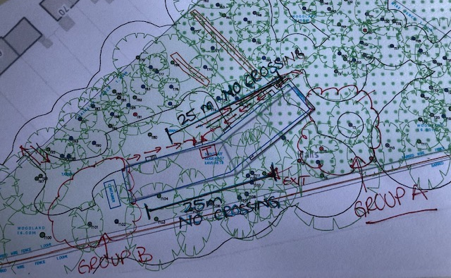

During AMBER, outdoor activities are preferred. Preferably a tent/shelter without sides should be provided outside first before Indoor activities can be undertaken.

Groups will consist of (at least) 2 adults and up to the maximum size of 15 young people. Groups could be based on Lodges, Sixes or Patrols. For example, this could equate to 15 young people and 5 leaders (YLs or adults). Adults are allowed to move between groups.

In addition, sections should plan to have 1 leader in charge. This person is responsible for ensuring that the control measures in the section risk assessment are being met. If the leader in charge is not the designated First Aider, then a second ‘spare’ adult holding a valid first aid qualification is required. For clarity: if every adult running a group holds a valid first aid qualification, then you do not require a central first aider.

We can accommodate 2 group meetings in the grounds of the hut in the area shown, east and west of the building (Circled in red).

As a Group, we’ll use OSM Events to allow us to regulate the number of young people (and if necessary, leaders) attending a face-to-face activity.

Section Meeting Times

It may be the case that meeting days and times will need to shift to allow for all young people to be involved in face-to-face activities whilst restrictions are in place, particularly if we would like to run weekly, evening sessions.

Remember, if sections plan to meet in locations other than the Hut another COVID-19 risk assessment must be submitted and approved before the activity can take place.

Willingness and Consent

Parents/carers will be made aware of our plans to resume face-to-face activities by way of a letter/email ‘home’ towards the end of the Summer Term.

The group will conduct a willingness to return survey of leaders and parents to assess parental support for virtual/blended/outdoor Scouting.

Once section COVID-19 risk assessments have been approved by the district we will use e-mail to gather explicit consent from parents, including detail of how to remove consent. Parents/carers should let us know if any member of their family is shielding at this point.

This consent will establish that parents/carers are happy with the arrangements/steps we are taking to keep their young person safe whilst taking part in face-to-face activities during the AMBER phase. Parents/carers will also confirm that their young person has read and understands the face-to-face Scouting code of conduct.

The Group Scout Leader will handle the process described above.

Once consent is given it will be recorded on the young person’s OSM record.

Until the consent shows on OSM the young person may not take part in face-to-face activities.

Subsequent consent will be required to move into the YELLOW and GREEN phases.

Communication

All sections will use OSM email/text functionality to contact parents/carers about activities. Parents/carers will be made aware that activities could change at the last minute and that they should check their email and section WhatsApp group before their young person travels to the meeting venue.
These methods of communication are familiar to both leaders and parents/carers.

The Group will ensure that all correct mobile phone numbers and e-mail addresses for parents/carers and leaders are on OSM, which is available to the leaders and on the WhatsApp groups.

Parents will be reminded to check the contact/medical details on OSM are correct.

